Question 3 (7 marks)

The diagram shows the graph of , where and the domain of is restricted to .

<EFOFEX>
id:fxd{04052a78-edea-42b3-b6e5-cc52af5dc8b4}

FXData:

</EFOFEX>

(a) Explain how to use the graph to estimate a solution to the equation . (1 mark)

(b) On the same axes, sketch the graph of . (2 marks)

(c) Determine a simplified rule for , stating any domain restriction(s). (4 marks)

Question 3 (7 marks)

The diagram shows the graph of , where and the domain of is restricted to .

<EFOFEX>
id:fxd{c6f51d72-bb61-4415-881d-8b7f909b2b11}

FXData:

</EFOFEX>

|  |
| --- |
| Solution (b) |
| See diagram for endpoints and curvature |
| Specific behaviours |
| ✓ LH part of curve from  ü RH part of curve from |

(a) Explain how to use the graph to estimate a solution to the equation . (1 mark)

|  |
| --- |
| Solution |
| Draw the vertical line and the -coordinate of the intersection of this line and the curve will be the solution.  *(Do not accept use of graph of inverse function)* |
| Specific behaviours |
| ü correct explanation |

(b) On the same axes, sketch the graph of . (2 marks)

(c) Determine a simplified rule for , stating any domain restriction(s). (4 marks)

|  |
| --- |
| Solution |
| Range of , , is domain of . |
| Specific behaviours |
| ✓ interchanges and cross multiplies  ü obtains expression for  ü obtains defining rule for inverse  ü states domain restrictions in terms of for inverse |

Question 7 (7 marks)

Consider functions and .

(a) Explain why is not a one-to-one function. (1 mark)

(b) State the domain and range of . (2 marks)

(c) Determine the domain and range of . (4 marks)

Question 7 (7 marks)

Consider functions and .

(a) Explain why is not a one-to-one function. (1 mark)

|  |
| --- |
| Solution |
| is a many-to-one function. For example, . |
| Specific behaviours |
| ✓ states many-to-one or uses examples to show not one-to-one |

(b) State the domain and range of . (2 marks)

|  |
| --- |
| Solution |
|  |
| Specific behaviours |
| ✓ correct domain  ü correct range |

(c) Determine the domain and range of . (4 marks)

|  |
| --- |
| Solution |
| Using result from (b) we require but since the natural range of is then for domain of we just need the restriction :  Use to obtain range of : |
| Specific behaviours |
| ✓ indicates that  ü correct domain  ü indicates restricted range of  ü correct range |

Question 3 (8 marks)

<EFOFEX>
id:fxd{0b85ba9c-030c-4ed1-ac14-4aa3799d632b}

FXData:
</EFOFEX>Function is defined as .  
  
The graph of is shown at right.

(a) Sketch the graph of on the axes above. (2 marks)

(b) State the domain and range of . (2 marks)

Function is defined as , and .

(c) Write an expression for and determine the domain and range of . (4 marks)

Question 3 (8 marks)

<EFOFEX>
id:fxd{1f45a6eb-5492-41ad-89bf-949eeca84671}

FXData:
</EFOFEX>Function is defined as .  
  
The graph of is shown at right.

|  |
| --- |
| Solution (a) |
| See graph |
| Specific behaviours |
| ✓ axis intercepts  ü endpoint clearly reflection of in |

(a) Sketch the graph of on the axes above. (2 marks)

(b) State the domain and range of . (2 marks)

|  |
| --- |
| Solution |
|  |
| Specific behaviours |
| ü correct domain  ü correct range |

Function is defined as , and .

(c) Write an expression for and determine the domain and range of . (4 marks)

|  |
| --- |
| Solution |
| Domain: and  Range: . Hence |
| Specific behaviours |
| ✓ expression for  ü uses and indicates  ü correct domain  ü correct range |

Question 7 (8 marks)

Consider the function , where and are constants.

The graph of has roots at and , a vertical asymptote and passes through the point .

Sketch the graph of , clearly showing the -intercept and equations of all asymptotes.

<EFOFEX>
id:fxd{cabf6e38-b73b-4b21-b624-67de35f1c107}

FXData:

</EFOFEX>

Question 7 (8 marks)

Consider the function , where and are constants.

The graph of has roots at and , a vertical asymptote and passes through the point .

Sketch the graph of , clearly showing the -intercept and equations of all asymptotes.

<EFOFEX>
id:fxd{c576a0f1-f916-47f6-b4e6-e3e5c319d6a5}

FXData:

</EFOFEX>

|  |
| --- |
| Solution |
| Use roots to determine numerator:  Use vertical asymptote to eliminate :  Use point to determine :  Express as a proper fraction:  Hence oblique asymptote is and . |
| Specific behaviours |
| ✓ uses roots to obtain numerator  ü uses vertical asymptote to relate and  ü uses point to obtain denominator  ü expresses as proper fraction  ü states correct equation for asymptote  ü plots roots, -intercept and both asymptotes  ü correct curvature of graph to left of vertical asymptote, through roots  ü correct curvature of graph to right of vertical asymptote, through |

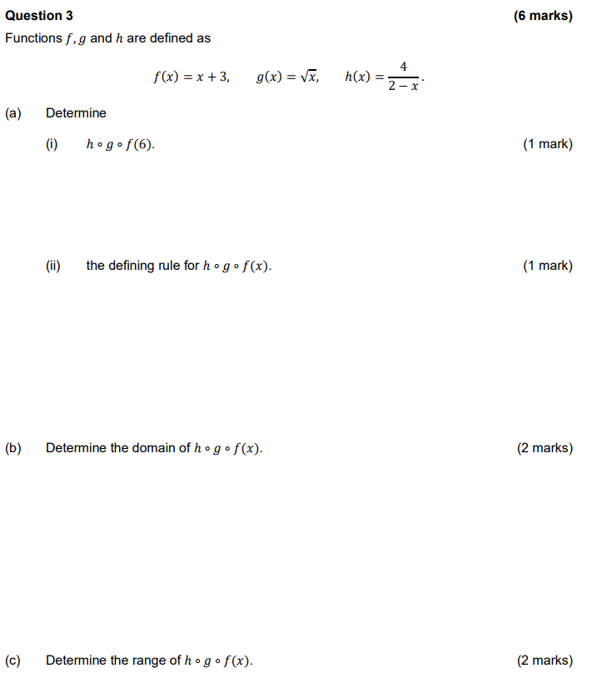

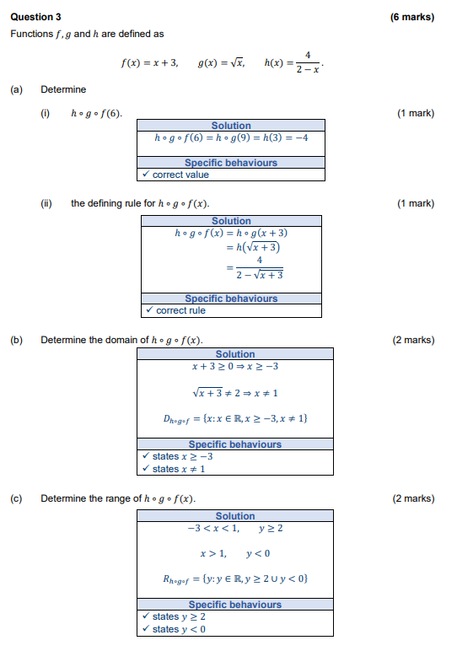

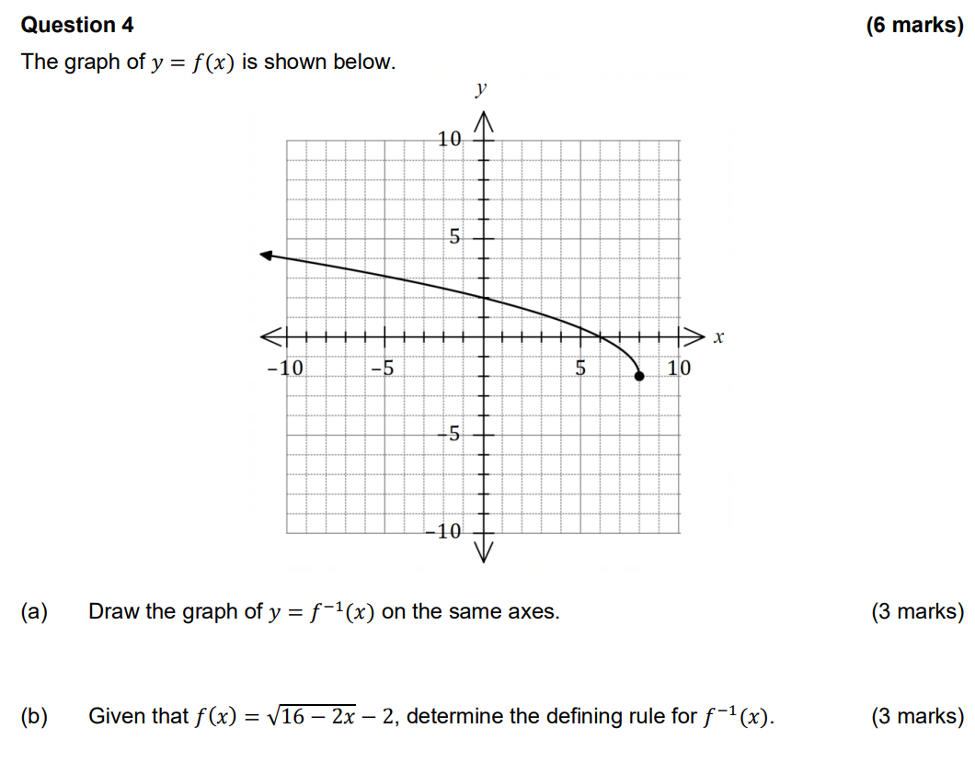

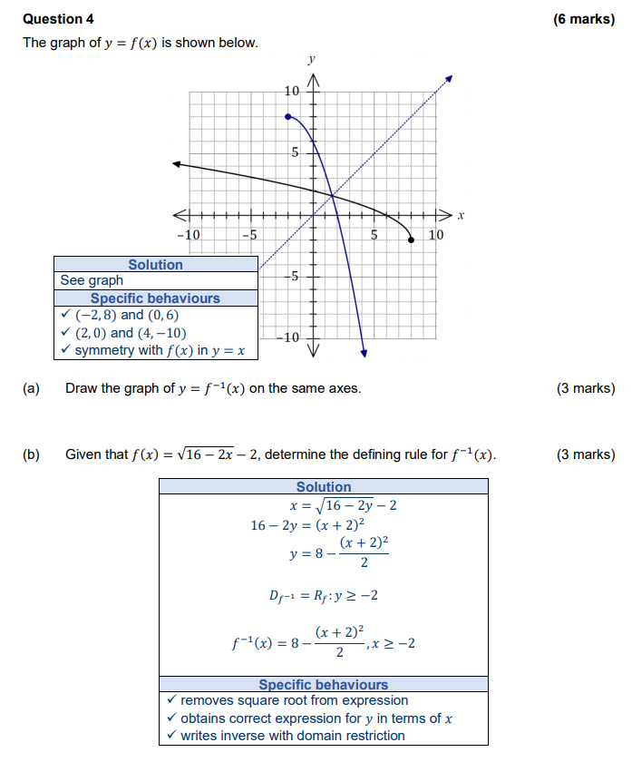

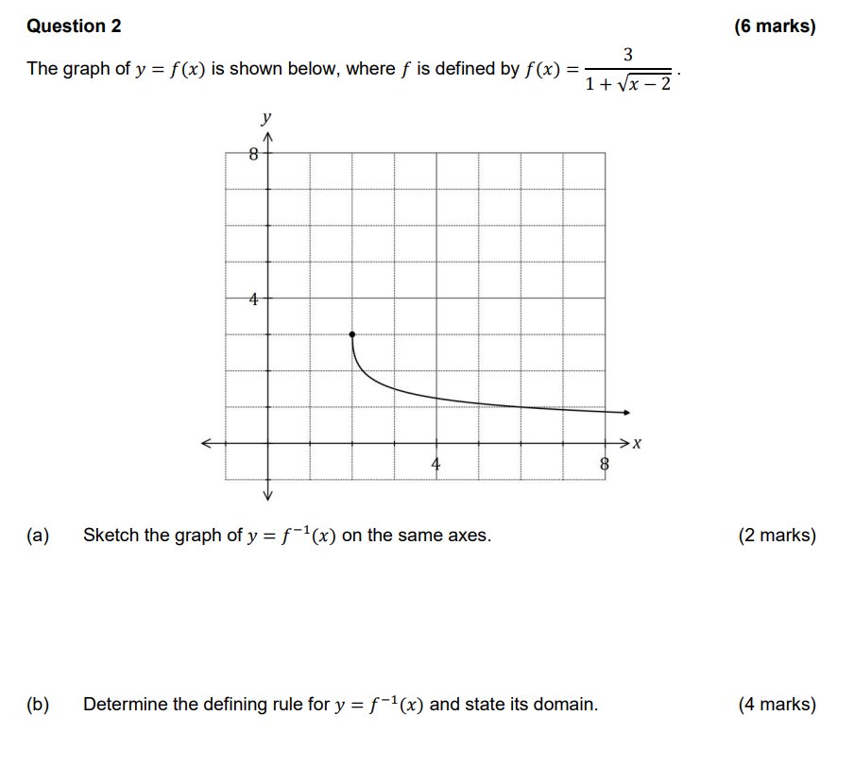

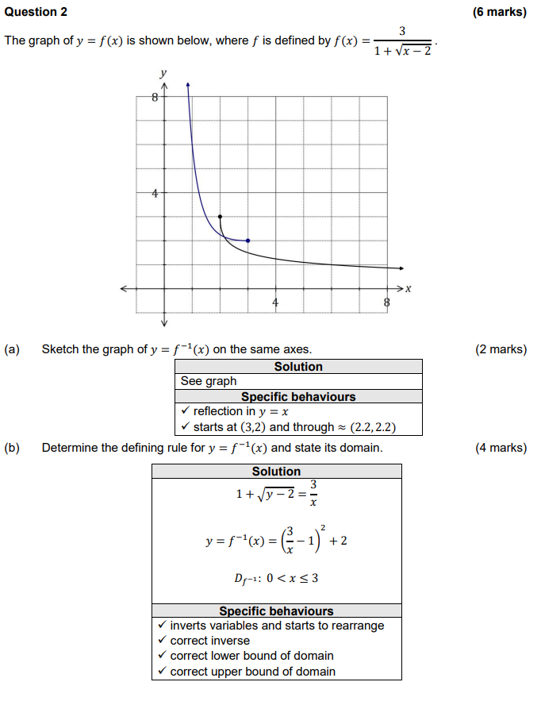

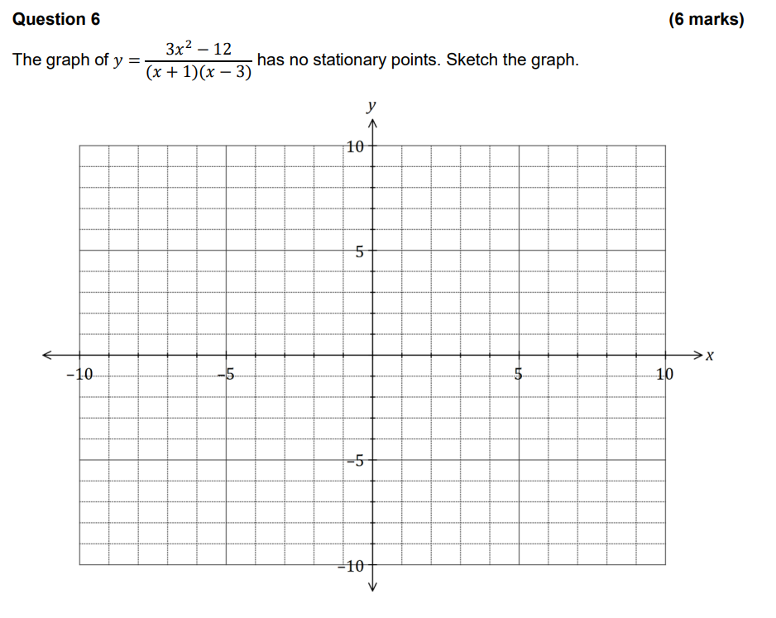

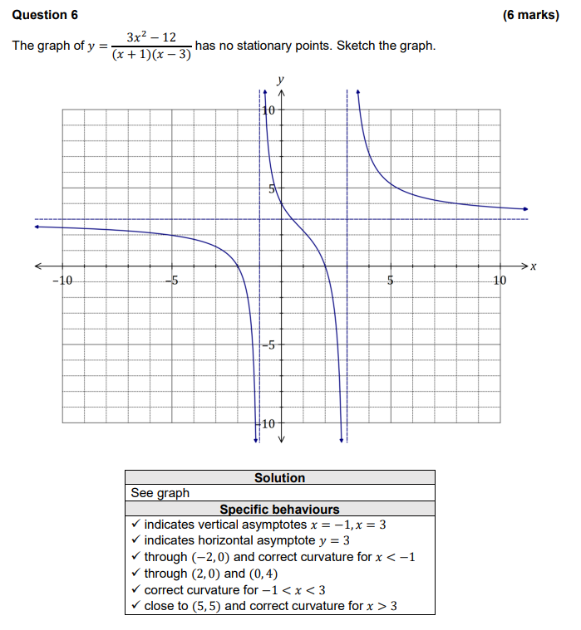

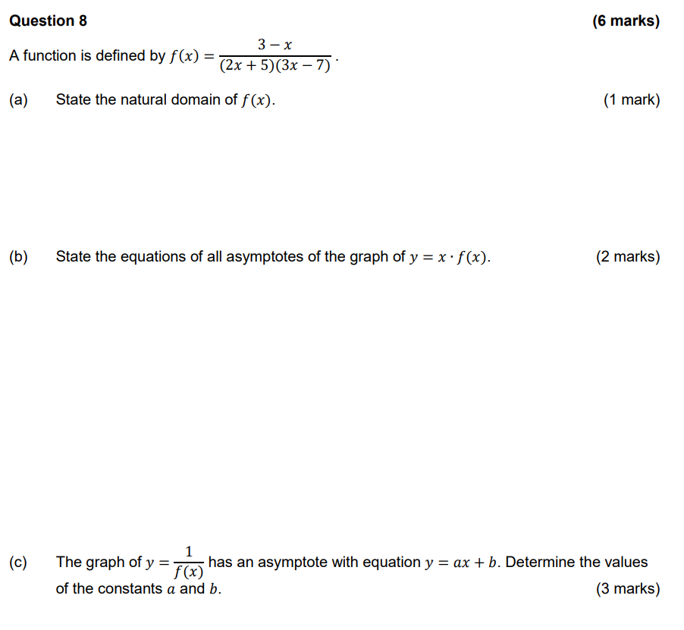

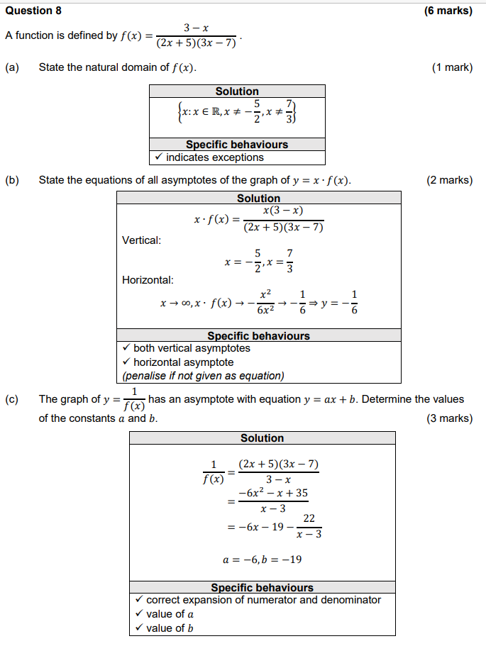

Question 6 (7 marks)

(a) Sketch the graph of  on the axes below. (2 marks)

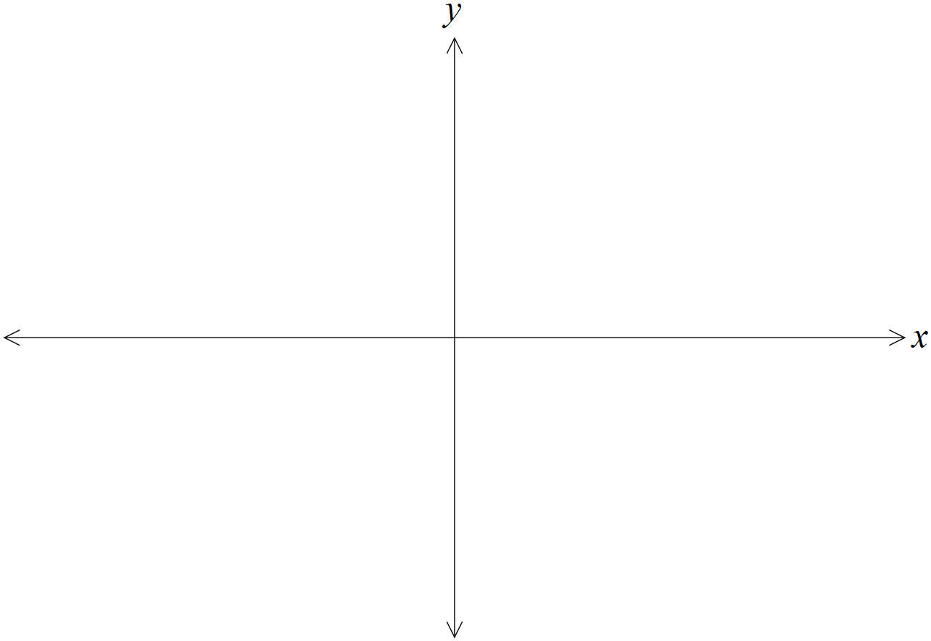

(b) Solve the equation . (3 marks)

(c) Solve the inequality . (2 marks)

Question 6 (7 marks)

(a) Sketch the graph of  on the axes below. (2 marks)

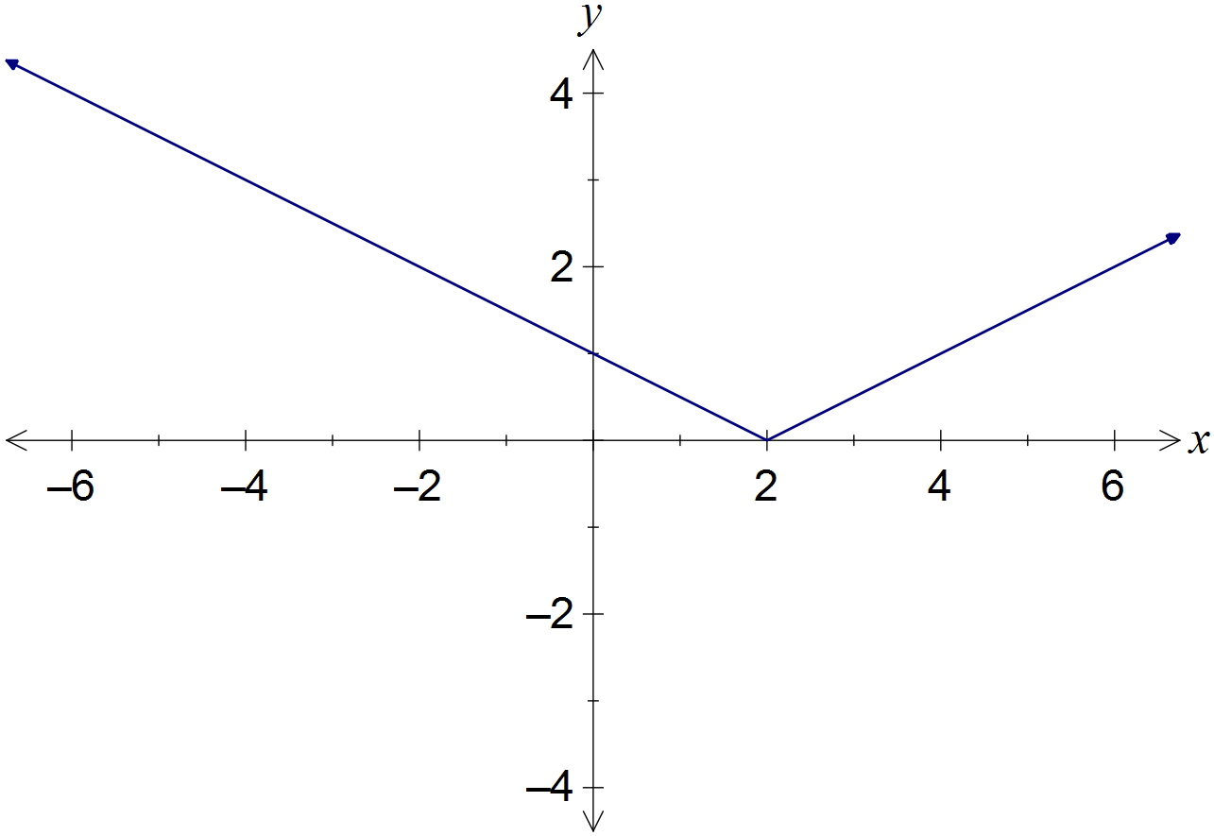

|  |
| --- |
| **Solution** |
| See diagram |
| **Specific behaviours** |
| ✓ v-shape with cusp at (2, 0)  ✓ correct y-intercept |

(b) Solve the equation . (3 marks)

|  |
| --- |
| **Solution** |
|  |
| **Specific behaviours** |
| ✓ separates into cases  ✓ solves first case  ✓ solves second case |

(c) Solve the inequality . (2 marks)

|  |
| --- |
| **Solution** |
|  |
| **Specific behaviours** |
| ✓ determines correct endpoints  ✓ states correct inequalities |